William Colon

4-2 Milestone Three:

Enhancement Two: Algorithms and Data Structure

Because I am not a developer and I do not have a great deal of experience in coding, I made the decision to complete this artifact using the programming language C++. To continue, the instructions that I found to be the most helpful were for C++, at least for me. One of my past classes, CS-320 Software Development Life Cycle, was the source of this artifact, which I chose to use. Specifically, it is about scheduling a meeting. As a result of the fact that it exhibits my knowledge in algorithms and data structures, notably through the development of an efficient sorting algorithm and the optimization of a data retrieval process that makes use of a balanced tree structure, I made the decision to include this artifact in my electronic portfolio. This is something I did since it demonstrates my level of expertise in these areas. Through the completion of this project, I have proved my expertise in comprehending the complexity of algorithms, selecting data structures that are ideal for particular tasks, and developing code that is both clean and functional. An improvement was made to the artifact by means of iterative testing and performance profiling, which led to a decrease in the complexity of the runtime and an increase in the scaleability of the system. Each and every one of these enhancements was created feasible when. This project reflects my analytical abilities as well as my dedication to the continual growth of writing processes. Taking everything into consideration, its purpose is to demonstrate both of these qualities.

I believe I have accomplished all the objectives I established at the onset of training, and I have received the recommendations. I have discovered numerous approaches for integrating algorithms into code, a task I find rather challenging. I am glad to announce that I successfully achieved the course outcomes I established for Module One. I successfully exhibited my understanding of significant algorithms and data structures by applying them in my artifact. The learning objectives were effectively aligned with the approaches and strategies I examined and implemented, including efficient sorting procedures and data management. Based on my experiences and the input gained during this module, I aim to update my outcome-coverage plans to include a more comprehensive exploration of graph algorithms and their real-world applications.

During the enhancement and modification of the artifact, I recognized the significance of iterative development and the utility of debugging and optimization methods. Every rewrite enhanced my comprehension of the performance of numerous algorithms under differing settings, underscoring the necessity to evaluate both time and space complexity in my selections. A notable problem I encountered was reconciling code efficiency with readability; aiming for performance occasionally resulted in less intuitive code. Furthermore, addressing unforeseen issues in the data structure implementation underscored the importance of comprehensive testing and the capacity to modify and refine plans in response to outcomes. This experience enhanced my problem-solving abilities and highlighted the significance of planning and documenting modifications during the development process.

I added a “database”

First the info was embedded in the code

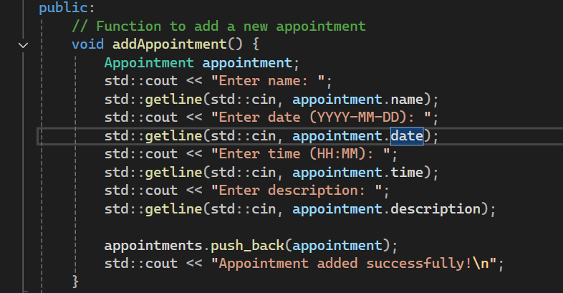

I restructured the function more structured

